x

**Sri Lanka Institute of Information Technology**

Faculty of Computing

Department of ISE

Group project undertaken in partial fulfillment of the requirements for the BSc

Degree in Cyber Security

Information Security Project – IE3092

Camouflage

IT18123296 – Shamry M.N.M

IT18133646 – De Silva M.W.D.S

**The Camouflage**

**Introduction**

Capture The Flag (CTF) is a sort of Information/Cyber security event or competition that challenges to get or find a specific text that might be hidden on a server. This specific text is called the **flag**. Attackers should be capable of performing some hacking skills like reverse engineering, cryptography, exploitations, forensics to find the flag.

There are two main common types of CTFs; namely; Jeopardy-style CTFs and Attack-Defense CTFs

Computer security represents a challenge to education due to its interdisciplinary nature. Topics in computer security are drawn from areas ranging from theoretical aspects of computer science to applied aspects of information technology management. This makes it difficult to encapsulate the spirit of what constitutes a computer security professional.

One approximation for this measure has emerged the ‘capture the flag’ competition. Attack-oriented CTF competitions try to distill the essence of many aspects of professional computer security work into a single short exercise that is objectively measurable. The focus areas that CTF competitions tend to measure are vulnerability discovery, exploit creation, toolkit creation, and operational tradecraft.

A modern computer security professional should be an expert in at least one of these areas and ideally in all of them. Success in CTF competitions demands that participants be an expert in at least one and ideally all of these areas. Therefore, preparing for and competing in CTF represents a way to efficiently merge discrete disciplines in computer science into a focus on computer security.

**Objective**

The objective of this project is to create a competitive environment which can be used to train or practice a drill for SEO analyst, military cyber experts, and for pentesters to teach how an application of Steganography will happen. This can help sharpen the tools they have learned.

**Theme**

Camouflage is based on Goosebumps movie, which the player has to find all the flags in each level and destroy all the monsters. There are 10 main cities in a county which each and every city has fierce monsters destroying the whole cities. You have only got eight hours to save the cities. To destroy the monsters you must have to complete all the challenges. Once you reach the last level and get the flag, all the monsters will destroy. And all the cities will be protected.

**Camouflage Walkthrough**

**LEVEL 1**

Main target of the level one is a steganography, which to extract the image, contains the flag which is hidden in an image.

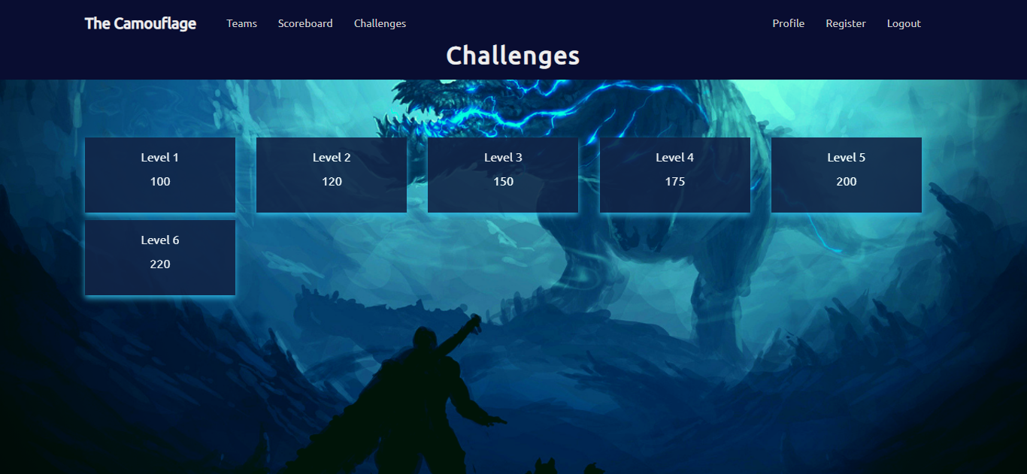Figure 1.1

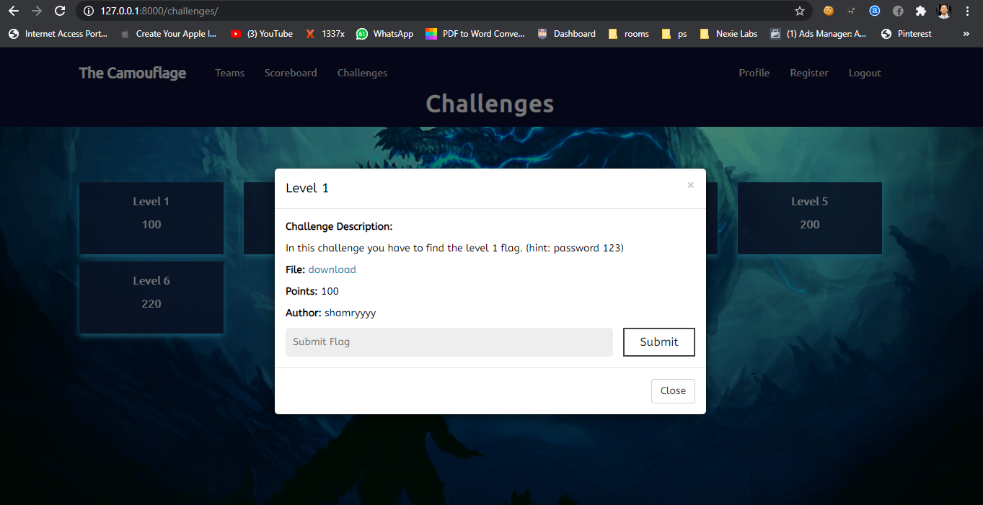Figure 1.2

Level one is to find the flag which is hidden in the image. Challenge description has given the hint to find the flag.

First download the image in the Level one.

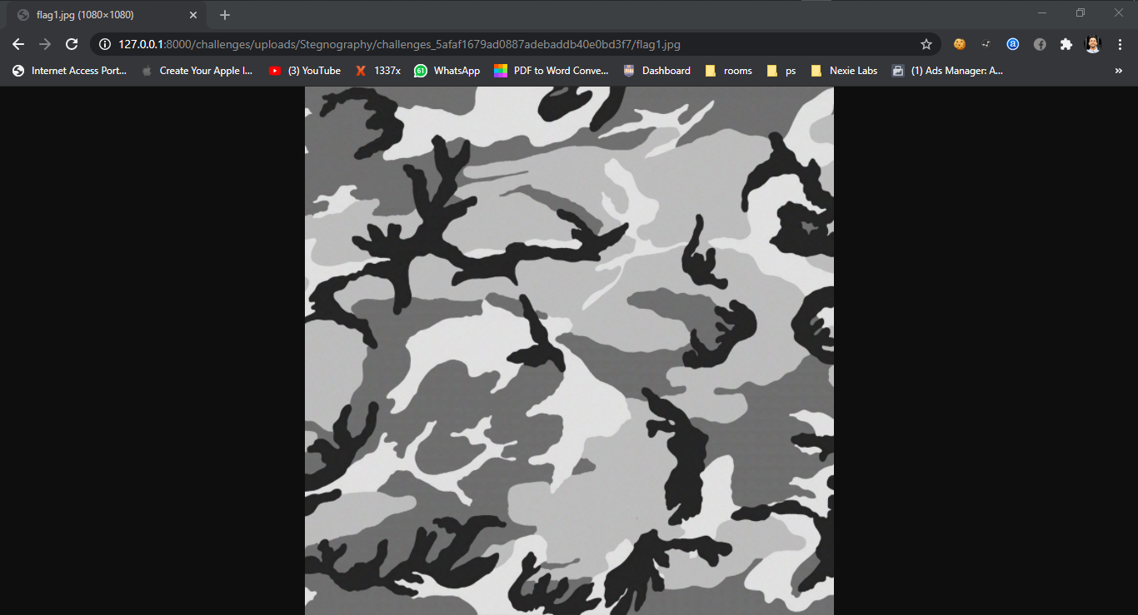Figure 1.3 *Downloaded Image*

This is the downloaded image in the level one to which is to find the flag, hidden in this image.

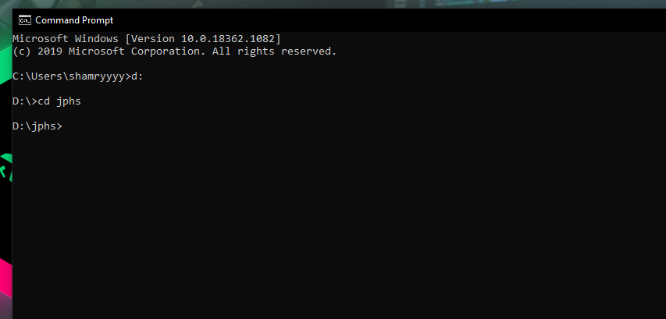

Figure 1.4

Use the **JPHS** tool to hide and seek data in an image.

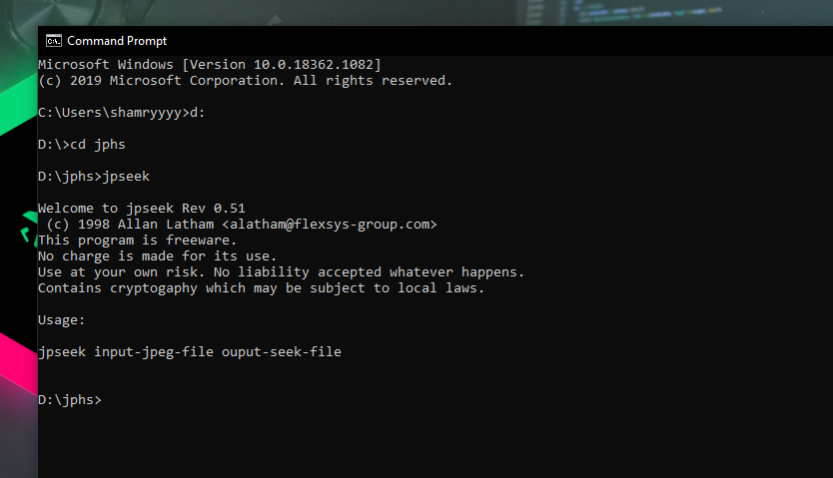

Figure 1.5

Using JPHS tool, decode the flag.

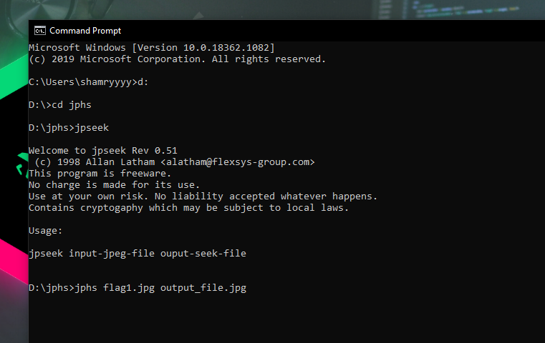

Figure 1.6

Use ‘jpseek’ command to seek the data which is hidden in the image.

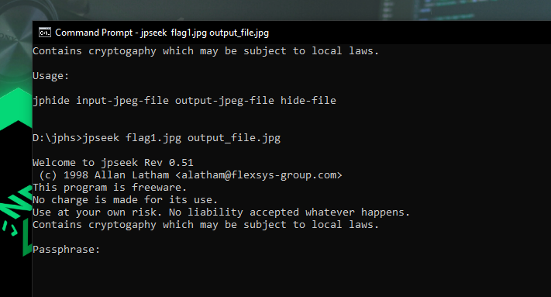

Figure 1.7

Here type the command ‘**jpseek <downloaded image name.jpg> <we can give any name here.jpg>**’

Then this will seek the data and store with the name we have given as below.

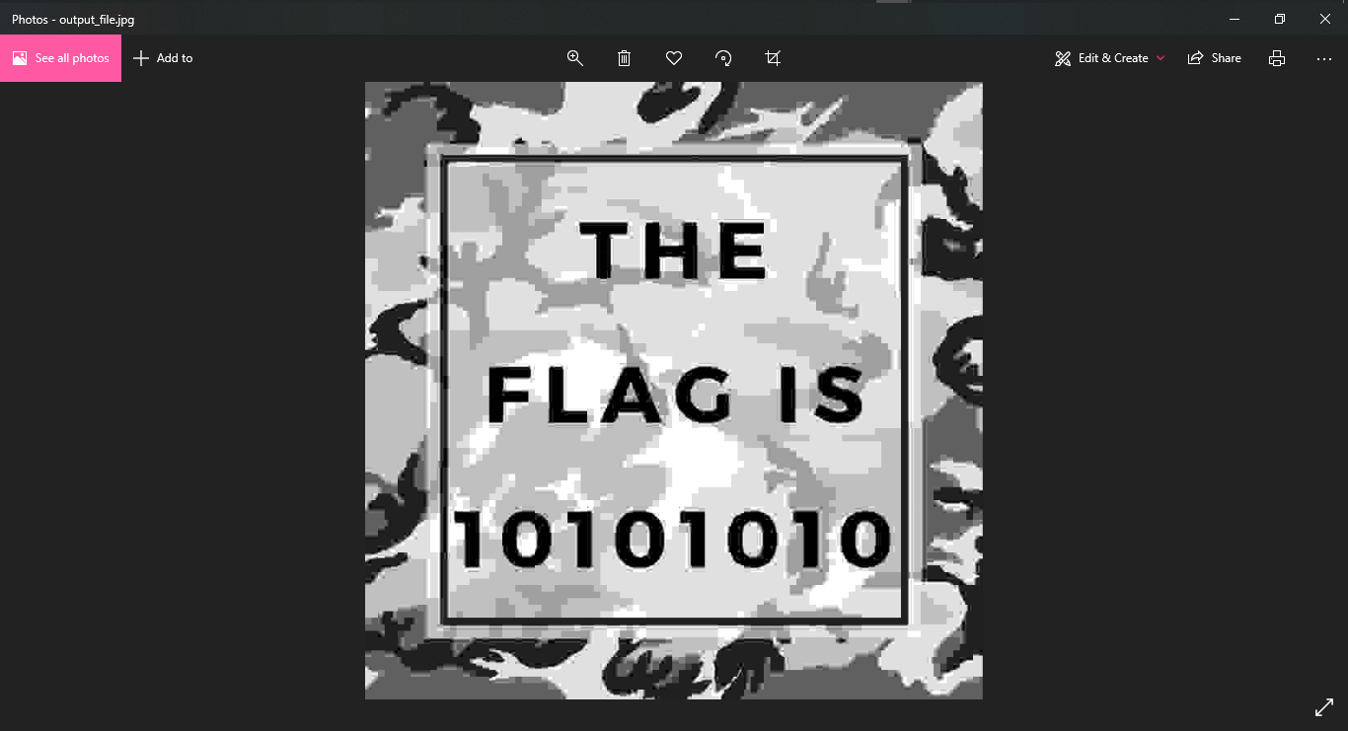Figure 1.8

This is the image which is extracted, containing the flag.

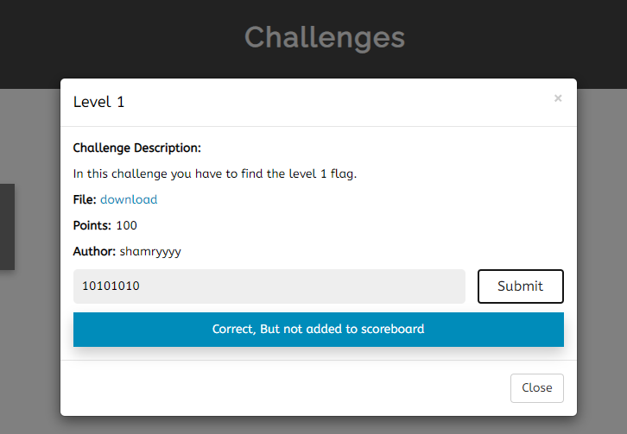

Figure 1.9

**The tools used in level one and their usage.**

**JPHS –** JPHSstandards for Jpeg hide and seek.Typically attackers and lots of programmers use JPHS tool to hide and seek data in an image. We have used the same tool to hide the flag in an image.

JPHS tool is made up of two programs which are JPHIDE and JPSEEK which allows to hide a message file in a jpeg visual image. The design objective was not simply to hide a file but rather to do this in such a way that it is impossible to prove that the host file contains a hidden file.

**JPHIDE** – uses the Blowfish crypto algorithm for least significant bit randomization and encryption to determine where to store the bits of a hidden file.

**LEVEL 2**

In this level, the flag is hid in a QR code, scan the QR code with a suitable QR code scanner and encrypt the code using Morse code.

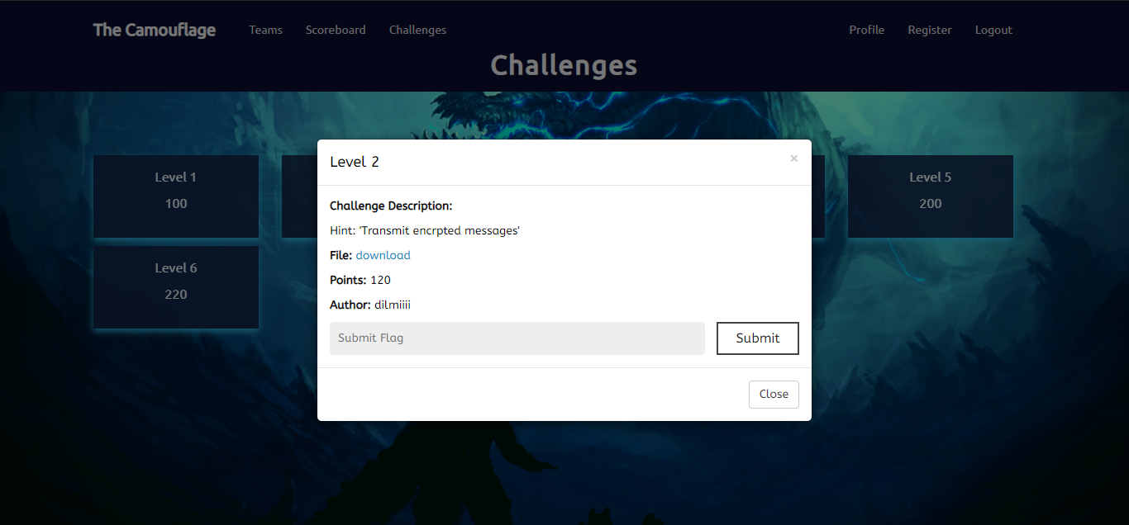Figure 2.1

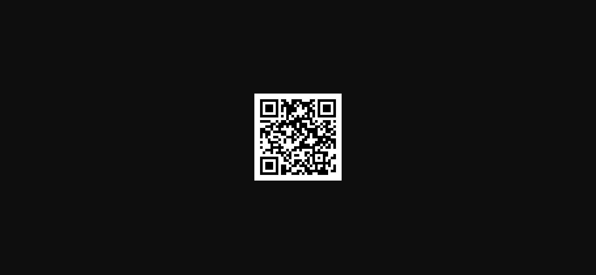Figure 2.2

Download the given QR code in the level.

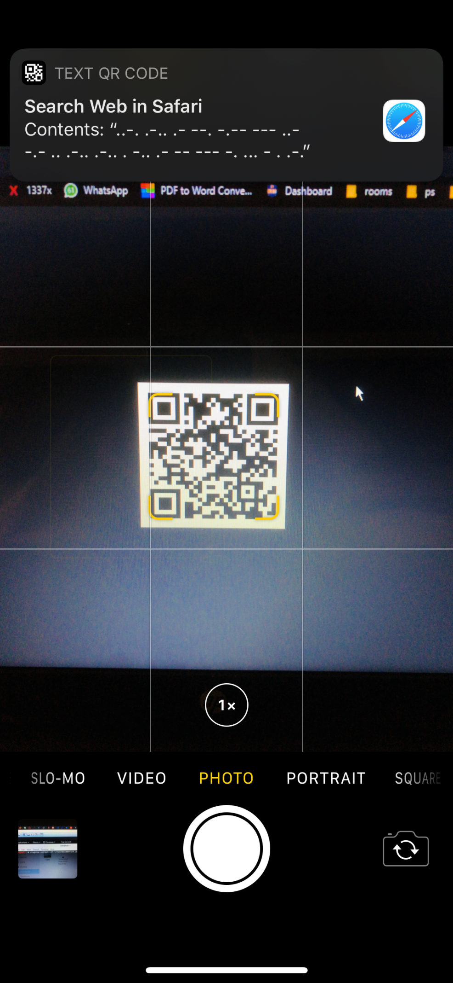

Figure 2.3

Now scan the QR code with a QR code scanner.

Then it will show the Morse code.

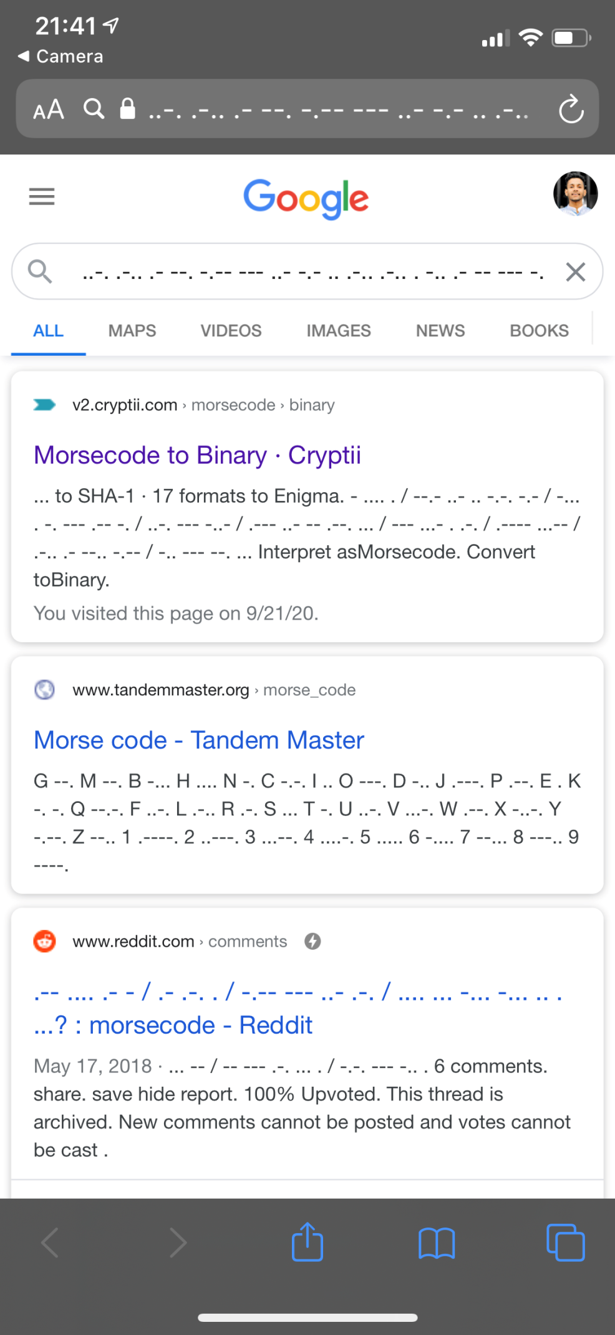

Figure 2.4

Then open a moose code decoder and decode above code. Then it will show you the fag

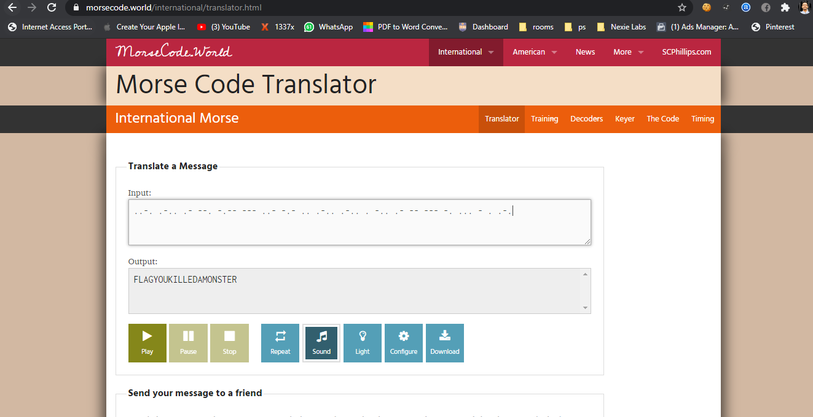Figure 2.5

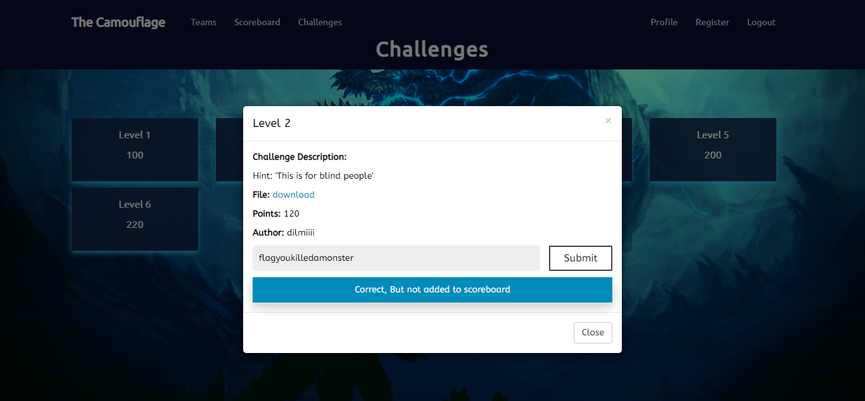Figure 2.6

Then submit the flag in the browser.

**LEVEL 3**

In this level we have encrypted a secret file along with an image. Using steghide tool to extract the image. Use base 64 ASCII decoder to decrypt the value.

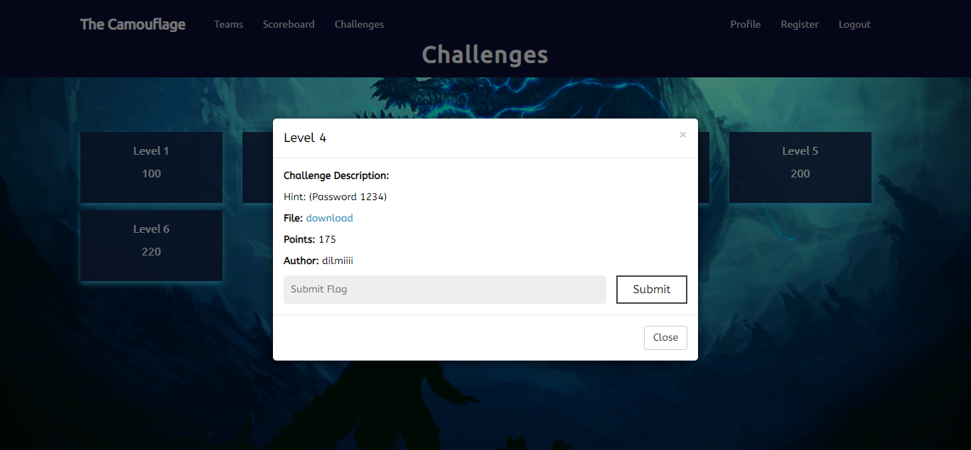Figure 3.1

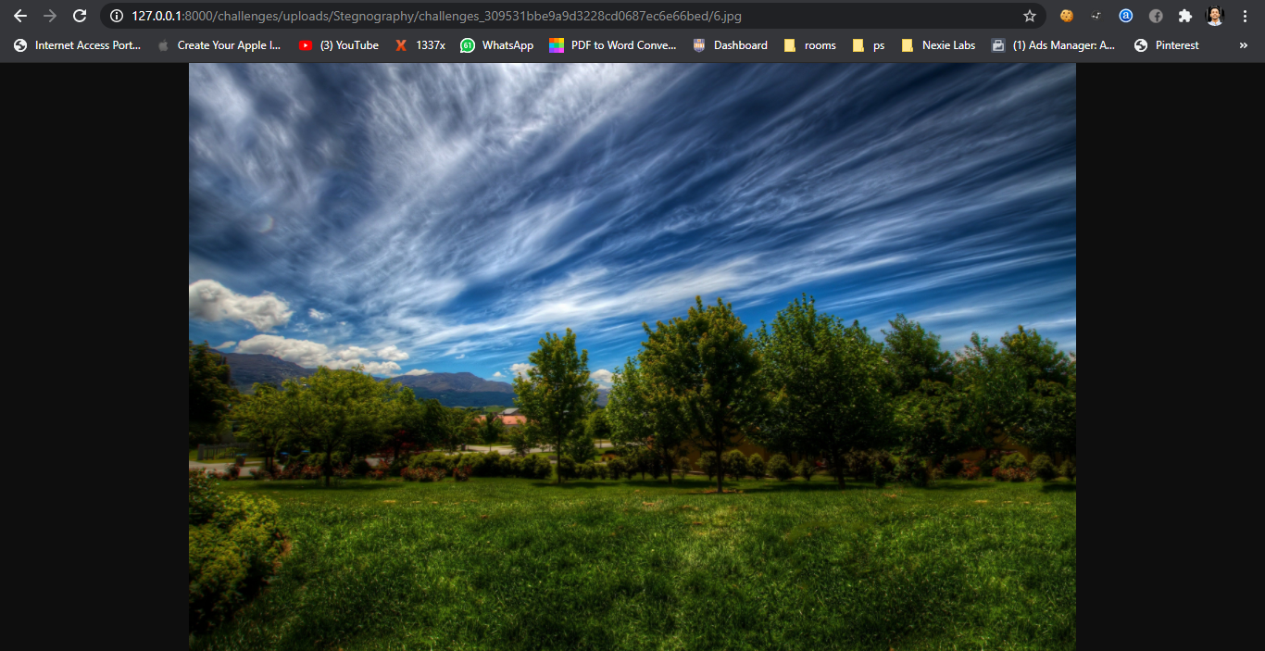

Figure 3.2

Download the file in the level.

To decrypt that we have to use a tool called **steghide** in kali Linux. After that use the below command to extract the file from the image.

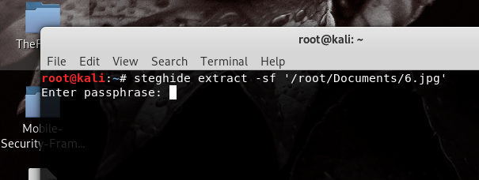

Figure 4.3

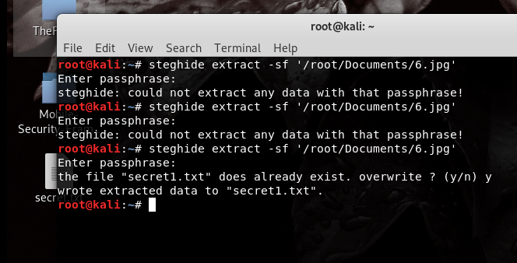

Figure 3.4

Then enter 1234 as the passphrase. Then you will get the secret file.

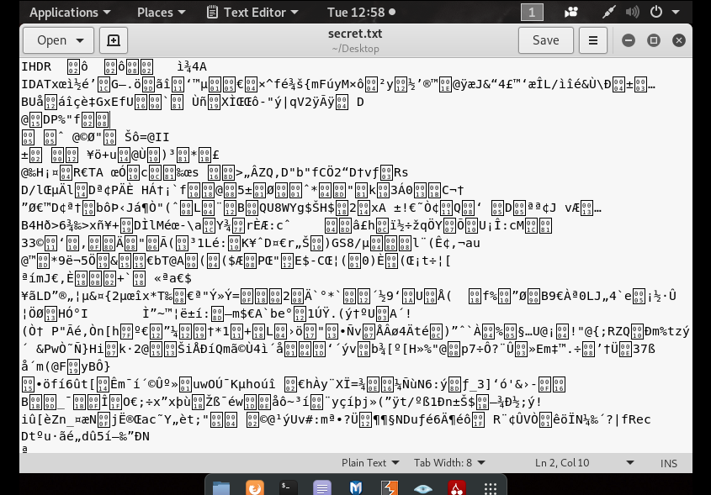

Figure 3.5

This is the secret file.

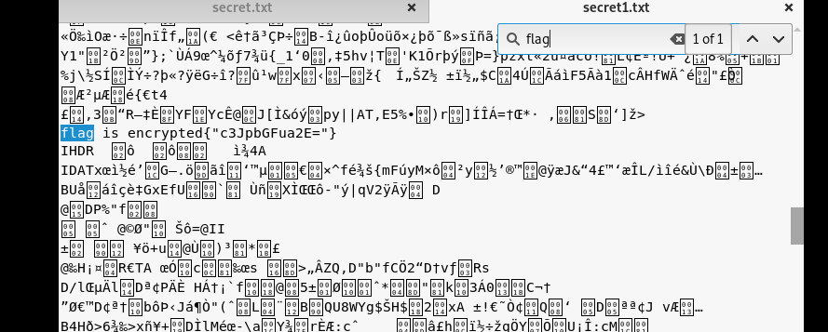

Figure 3.6

Then use ctrl + F to search the flag. You will a flag like below butt it is encrypted and we don’t know which language has been used to encrypt.

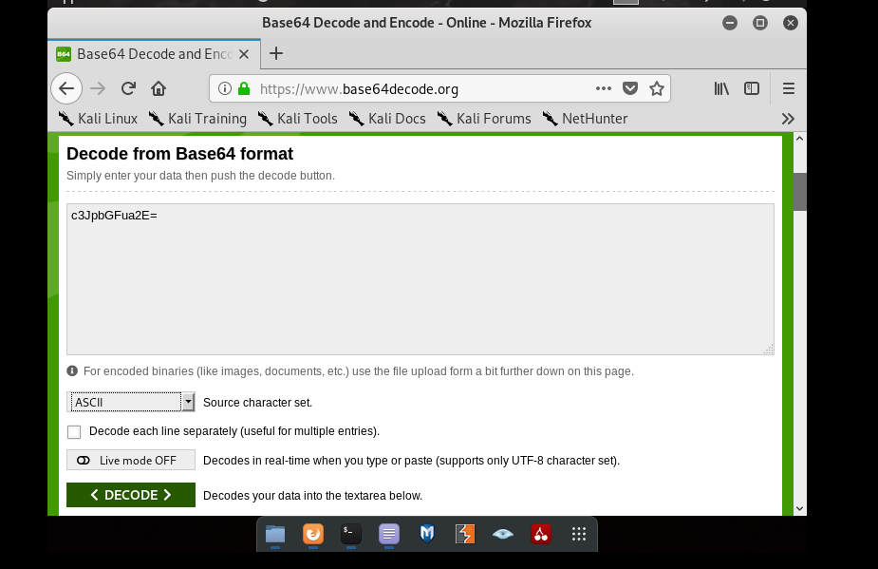

Figure 3.7

To decrypt above value we are going to use base 64 ASCII decoder. Open base 64 ASCII decoder and decrypt above value.

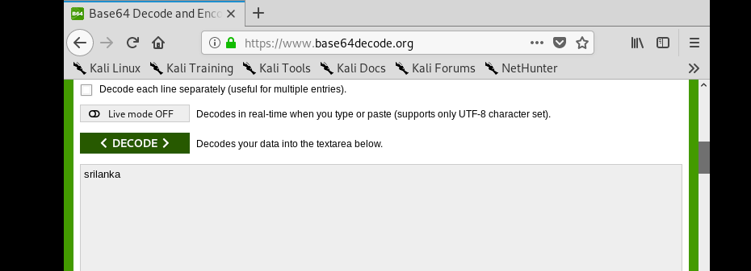

Figure 3.8

Then you will get the flag.

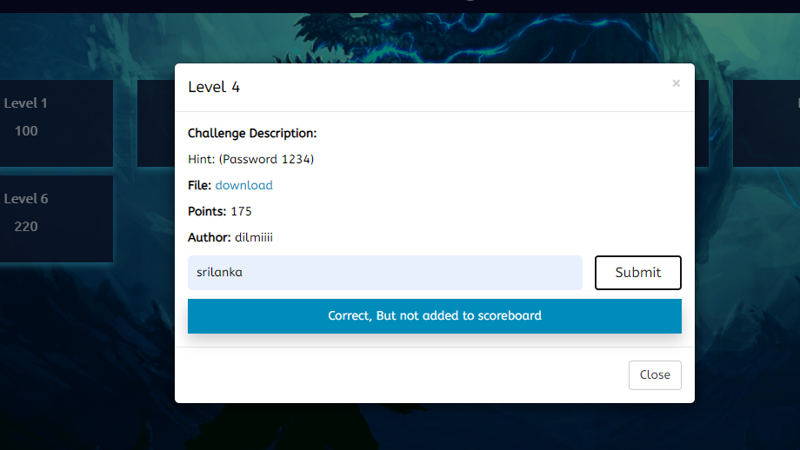

Figure 3.9

Then submit the flag for level four.

**The tools used in level one and their usage.**

**steghide** – this is a steganography tool that allows to hide confidential files inside an image or audio file with a passphrase.

**Base 64** – Base 64 is a binary to ASCI encoding scheme. It is designed to transfer functions in order to interpret data transmitted using Base64 encoding.

**LEVEL 4**

In this level the flag is hid in a way of encryption using braille code. Therefore should search for website to extract the hidden texts from embedded PNG. And decrypt the value and decode it using braille language. Then you will get the flag.

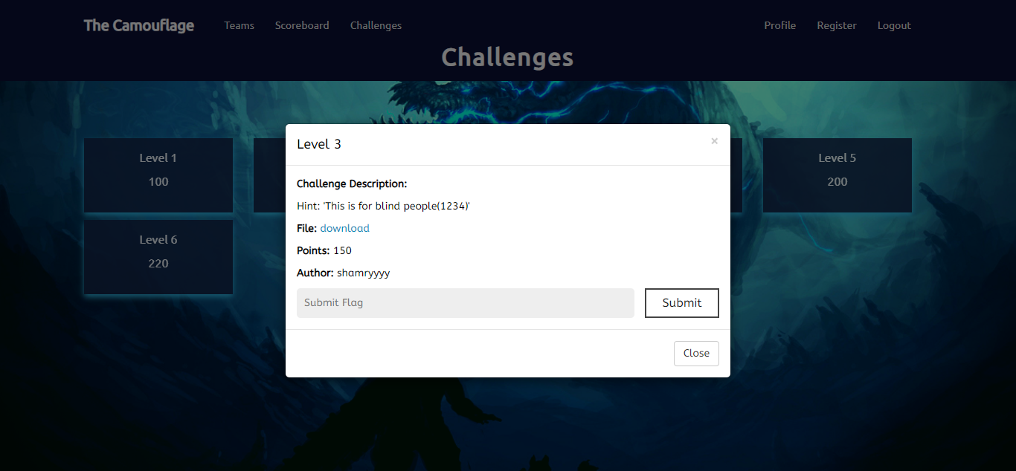Figure 4.1

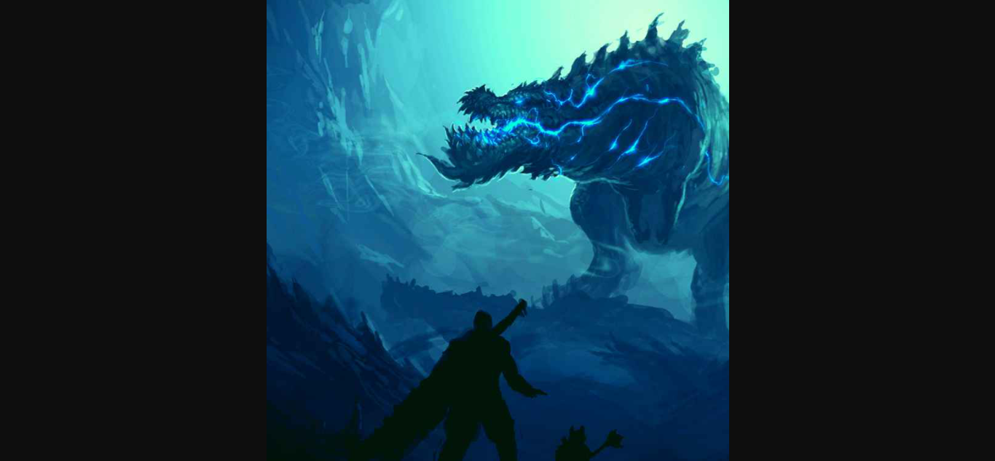

Figure 4.2

This is the embedded picture.

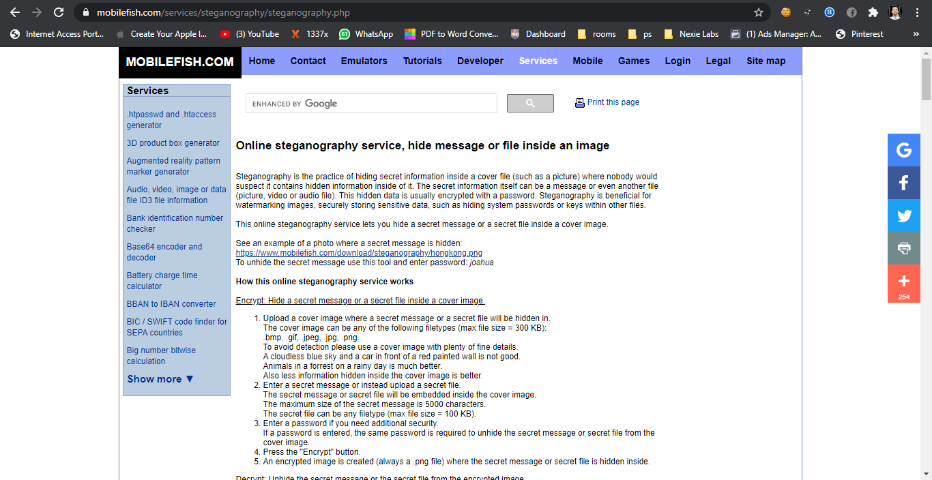Figure 4.3

There’s a website called mobilefish.com to extract hidden texts from embedded PNGs

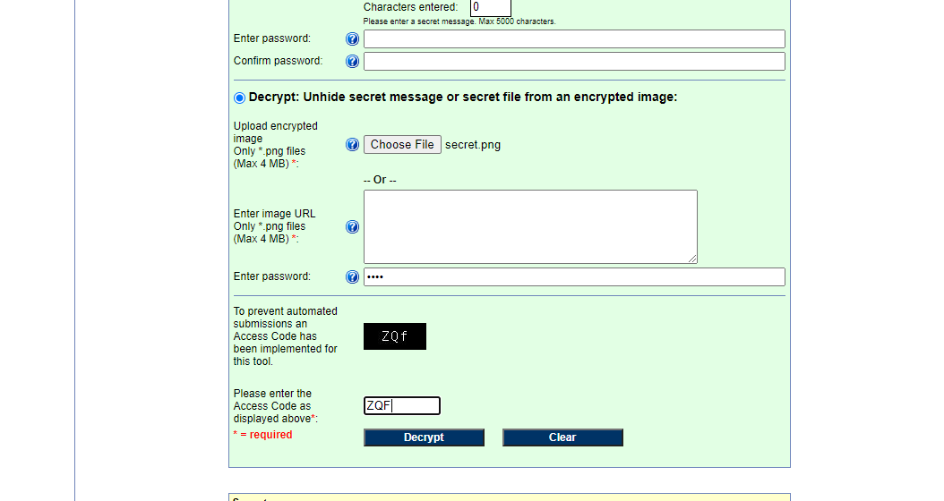

Figure 4.4

Upload the embedded image as shown below and enter the password as “1234”

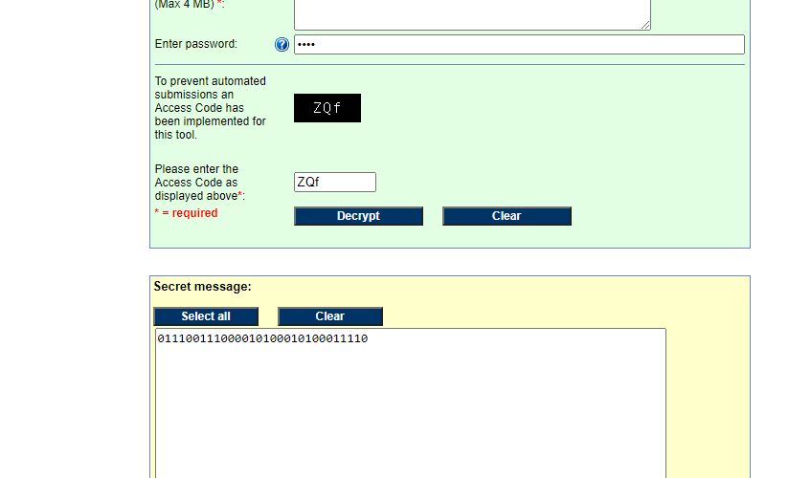

Figure 4.5

And then decrypt it. You will get a binary value, but this is not the flag.

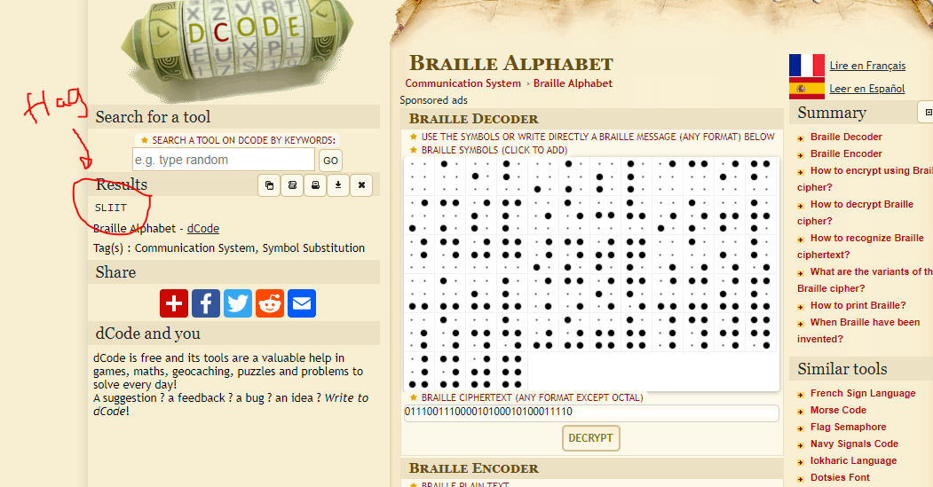Figure 4.6

In the challenge description there is a hint saying this is only for blind people. So that means the above binary value should have been encrypted using braille language. Now open a braille decoder in the browser. After that paste the binary value and decode, you will get the flag.

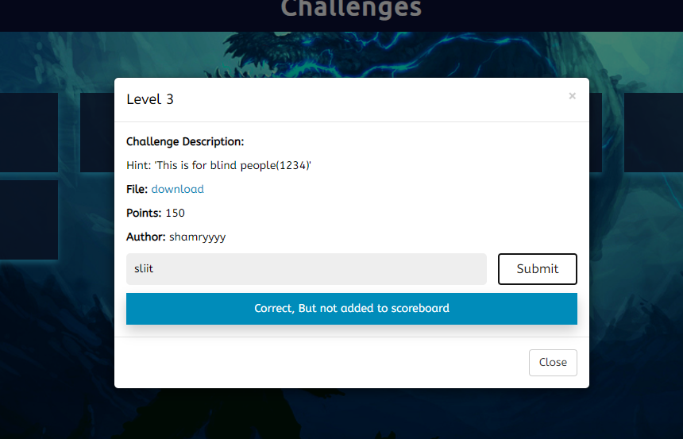Figure 4.7

And submit the flag in level 4.

**LEVEL 5**

This level is also targets the steganography technique which the flag is hid in text file. Download the text file and search for the flag in the text file and decode it using Caesar cipher decoder.

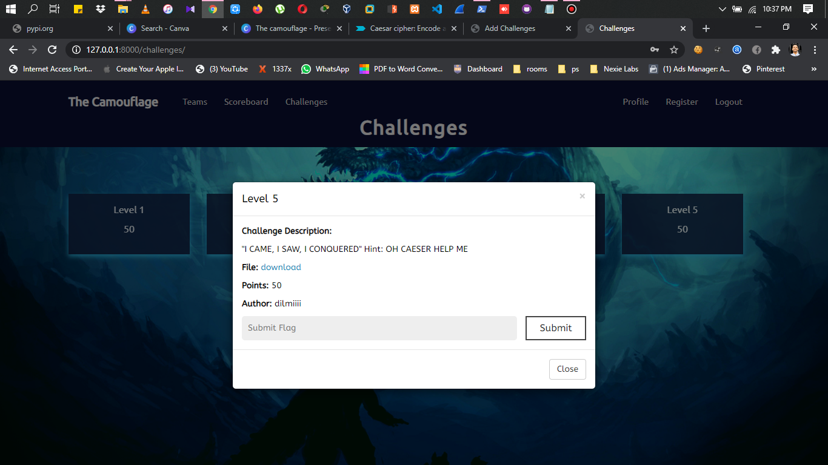Figure 5.1

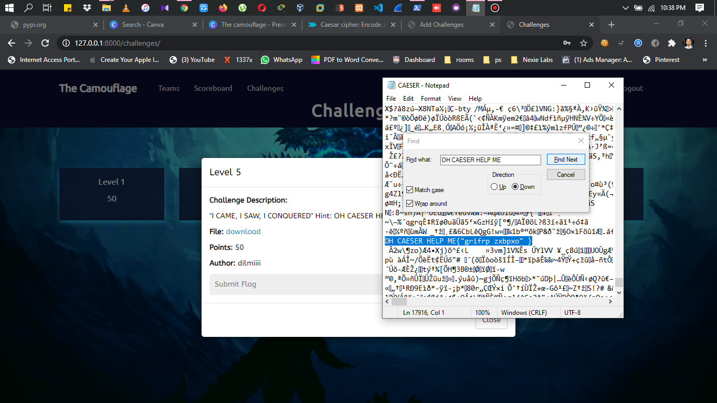

Figure 5.2

So download the file and search the flag inside the file.

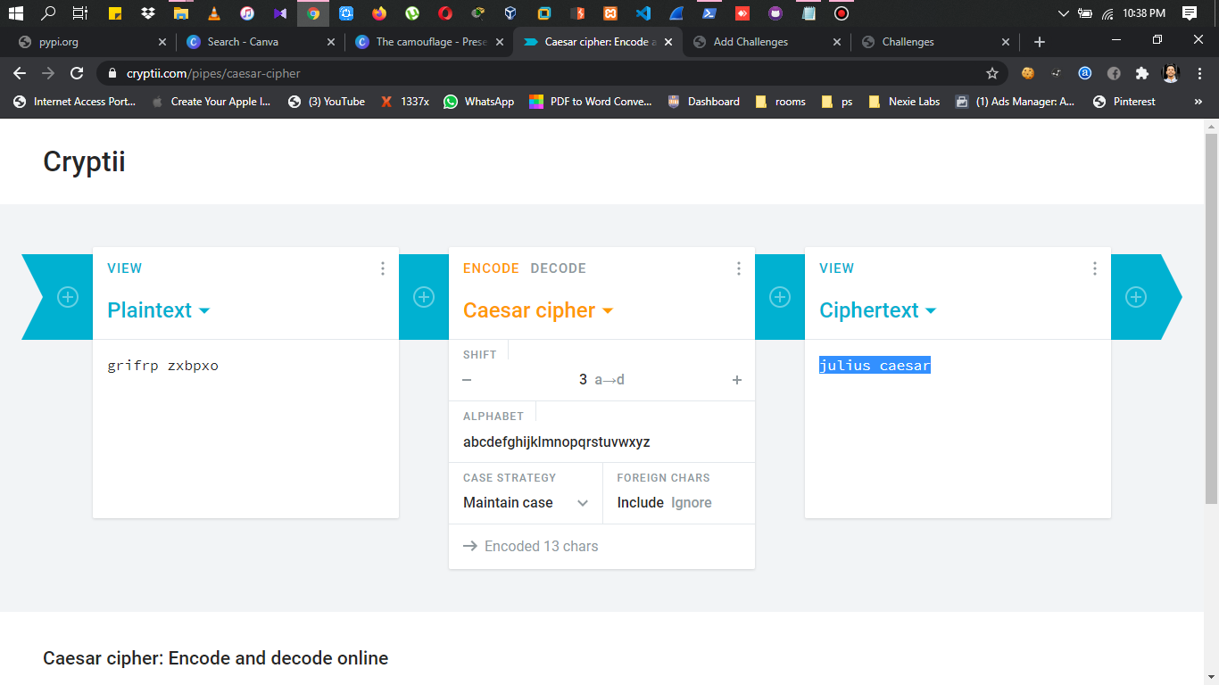

Figure 5.3

And then decode the flag using Caesar cipher online decoder.

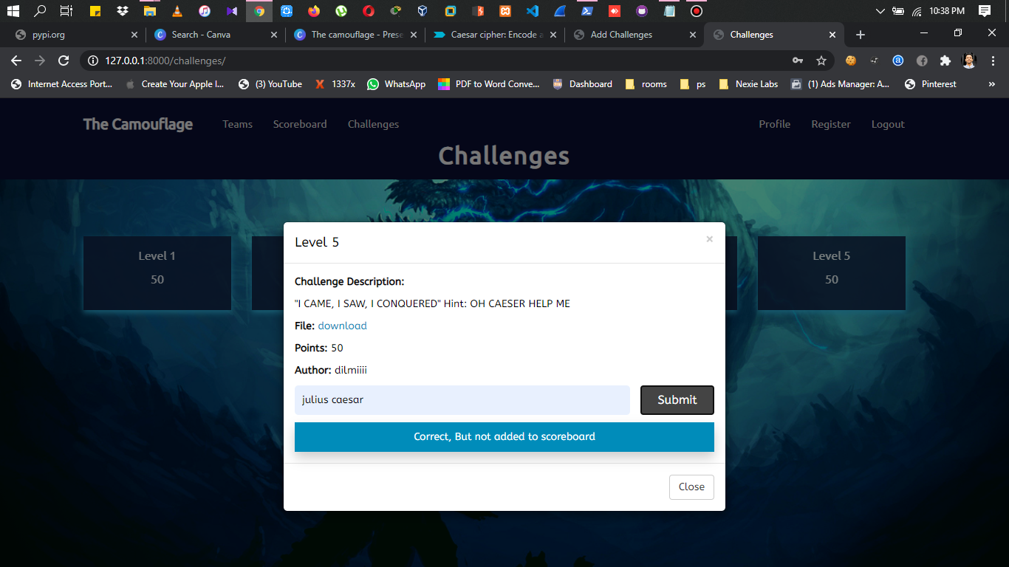Figure 5.4

Then submit the flag in the level 5.

**LEVEL 6**

In this level the flag is hidden in a file within a folder structure. So destroy the monsters find the flag by running a script in the command prompt.

Figure 6.1

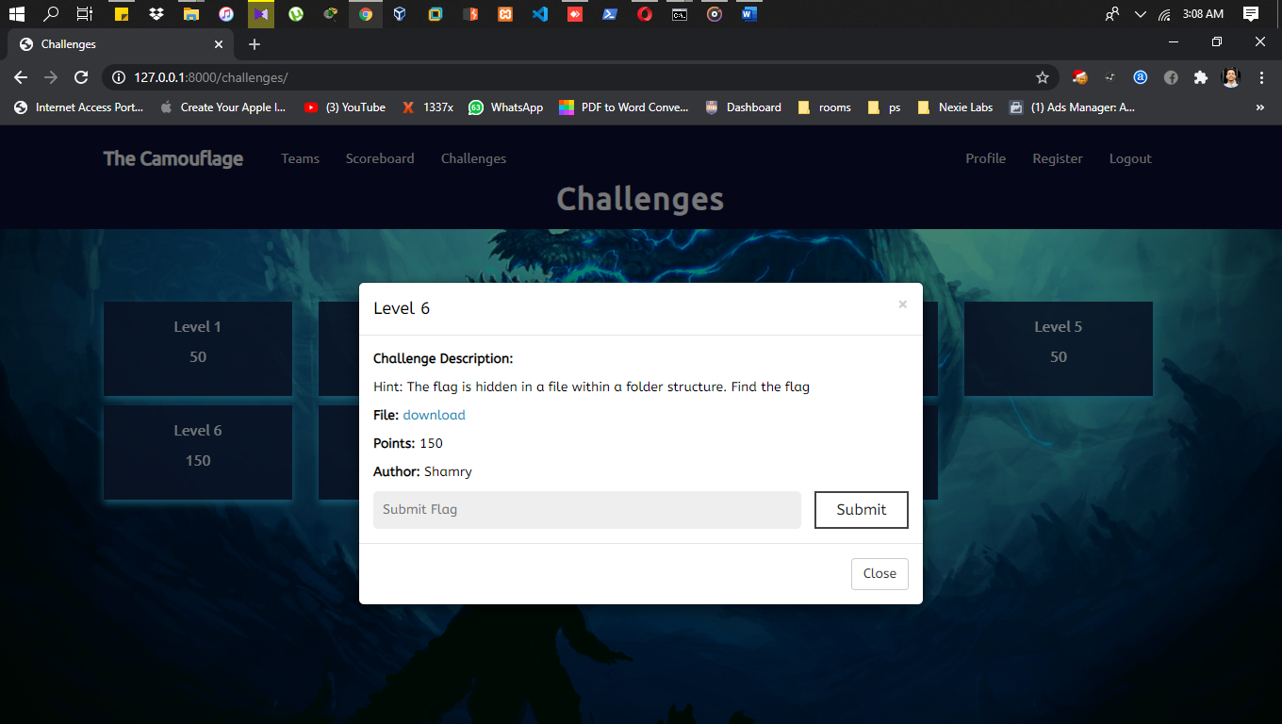

Download the file to any location in your PC.

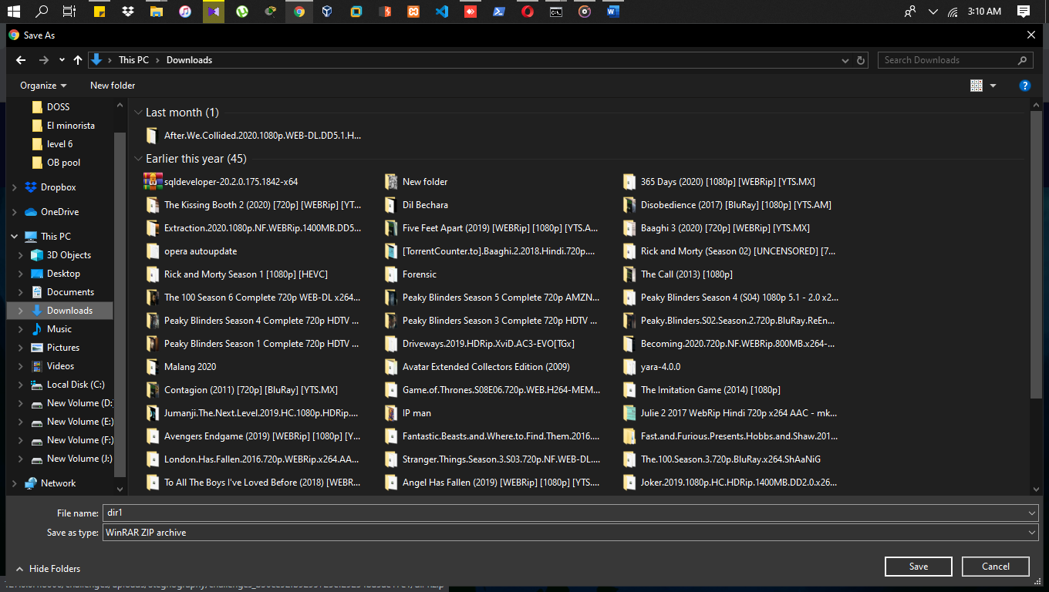

Figure 6.2

Extract the downloaded zip file.

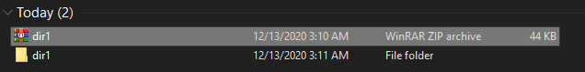

Figure 6.3

When you extracted the file you can see there is some number of folders inside zip file.

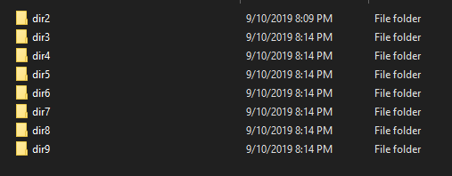

Figure 6.4

And inside these folders there are many files.

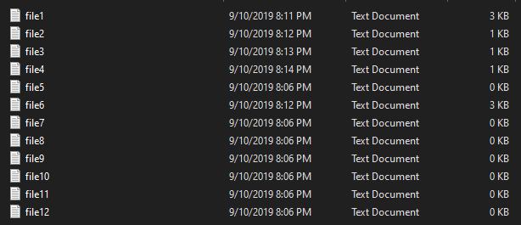

Figure 6.5

As in this level we need to find the flag by running a script in command prompt so open the command prompt and type the relevant command to get the flag.

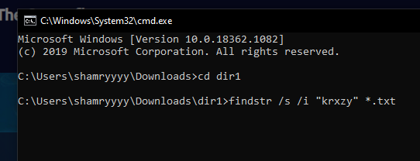

Figure 6.6

After compiling the command you can see there are many records or some flags. So simply check all the records about and you can find the flag for the level.

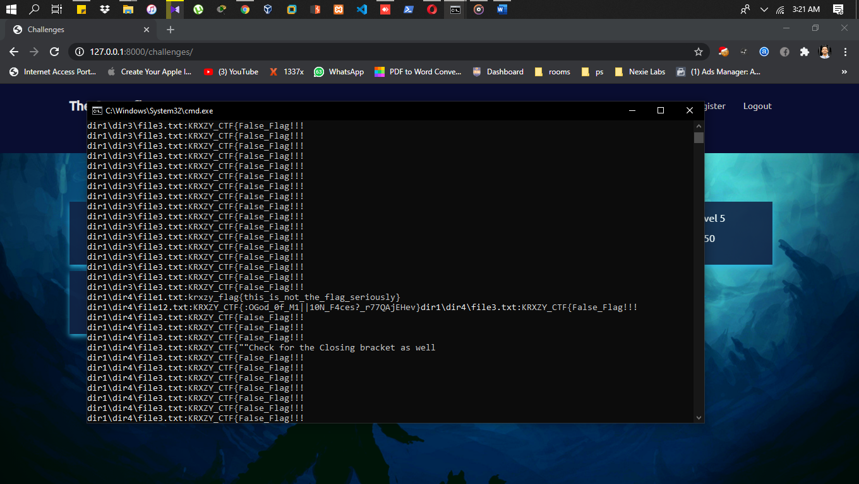

Figure 6.7

Once you check the records you can find the correct flag. The below image will show the flag.

And copy the flag and submit in the level.

**Flag**



**LEVEL 7**

The technology used for this level is reverse engineering. In this level there is a java code given. And compile the java code in the command prompt and capture the flag.

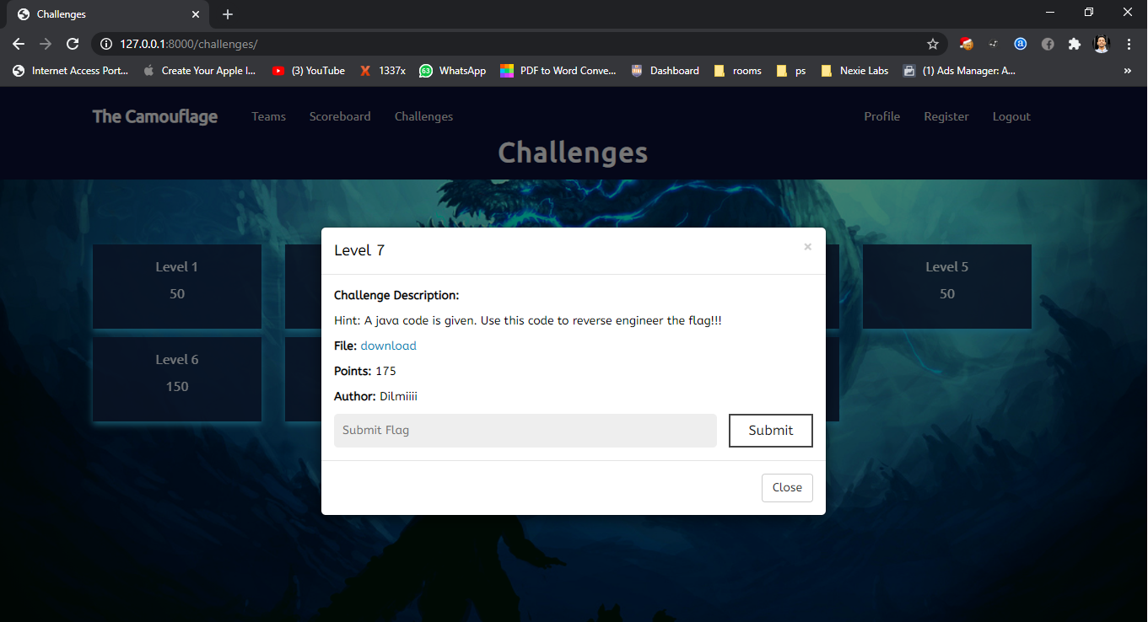

Figure 7.1

Download the file in the level.



Figure 7.2

Open the downloaded file with notepad++

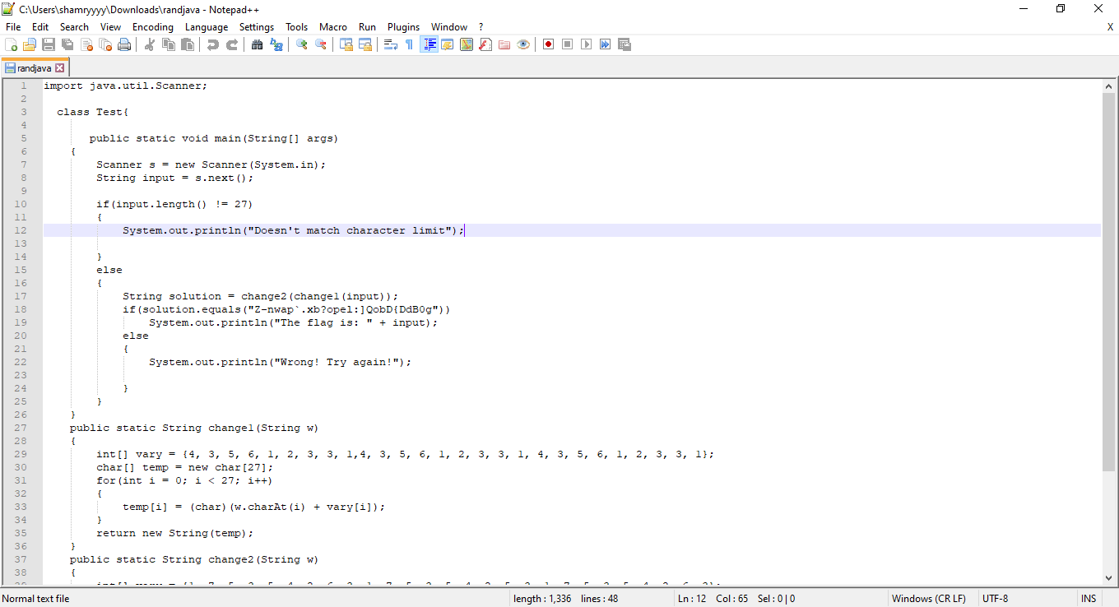

Figure 7.3

Type the following code in the downloaded file. And save the file.

**system.out.println(solution);**

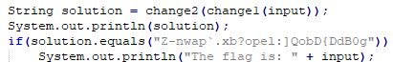

Figure 7.4

And open the command prompt in the right location and compile the file with javac.

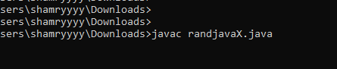

Figure 7.5

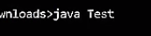

Figure 7.6

After compiling the above commands in the command prompt it will show the flag.

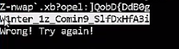

Figure 7.7

**LEVEL 8**

The technology used for this level is steganography. In this level, there is an audio file which is hid in a text file, which the text file is hid in an image.

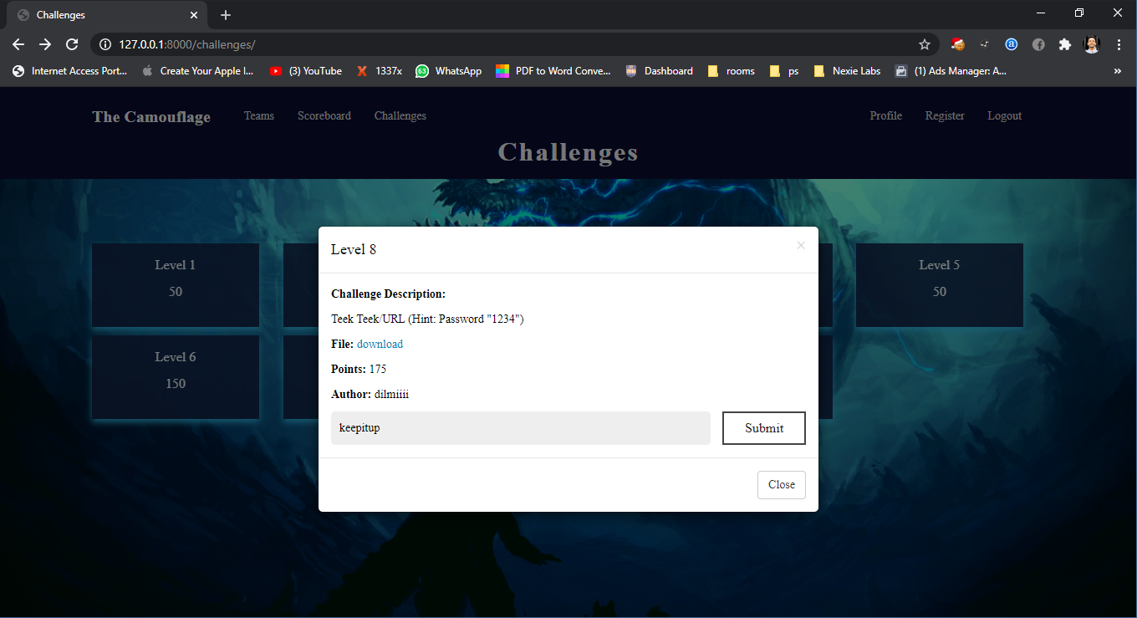

Figure 8.1

Download the image in the level.

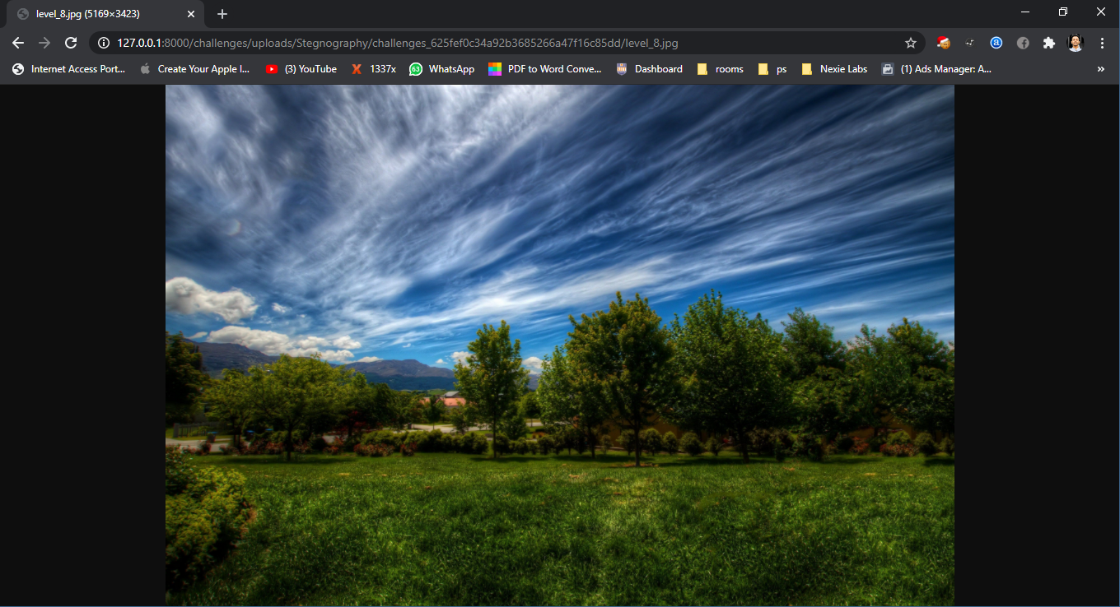

Figure 8.2

To extract the image we are using kali linux and steghide tool.

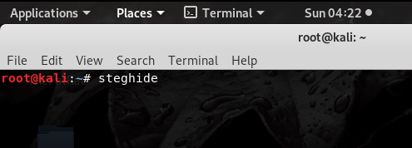

Figure 8.3

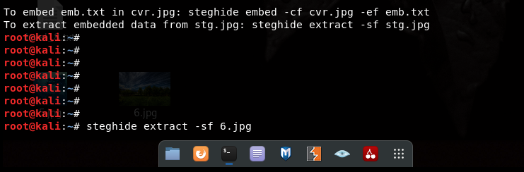

Figure 8.4

Once you have extracted the image it will ask for the password which is given in the level as the hint.



Figure 8.5

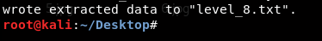

Figure 8.6

And this is the extracted image.

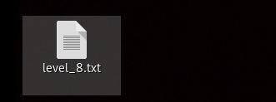

Figure 8.7

Figure 8.8

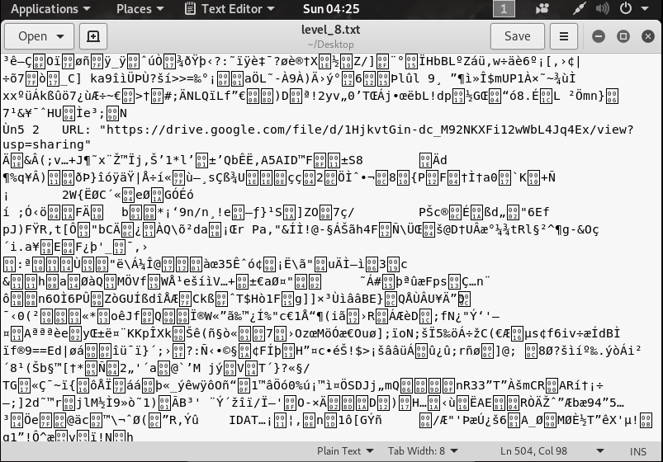

In the extracted file you can find a Google drive link which contains an audio file.



Figure 8.9

This is the audio file.

Figure 8.10

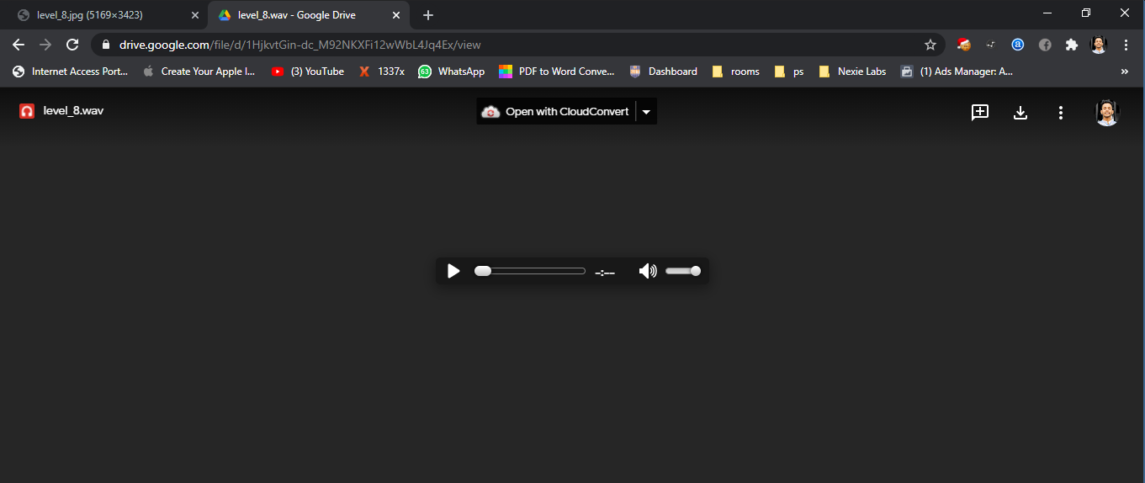

Download the audio file.



Figure 8.11

Figure 8.12

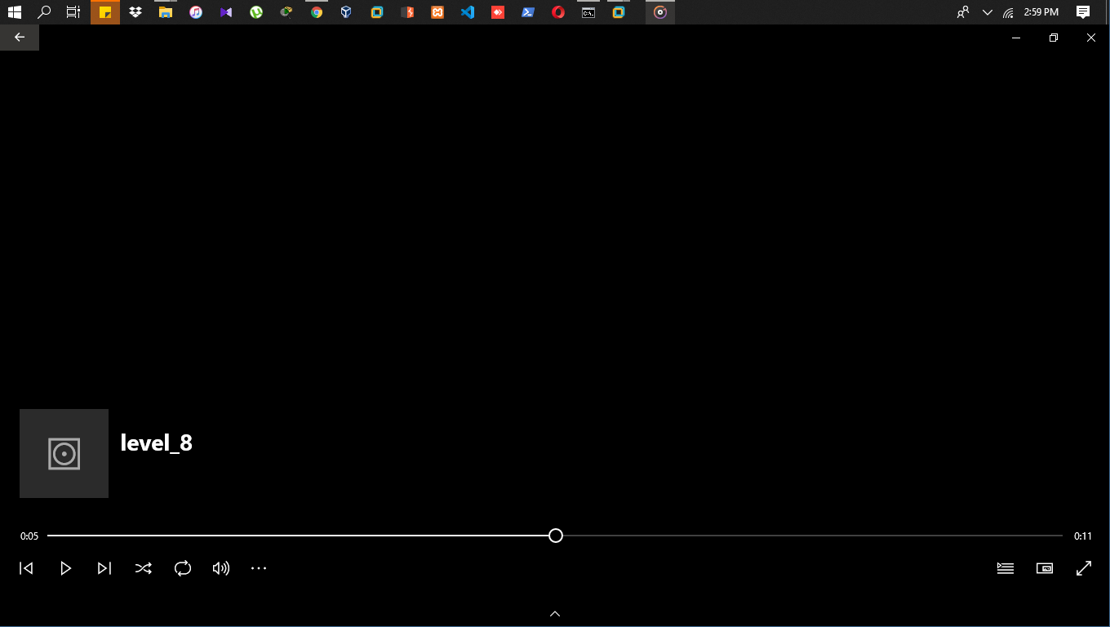

Using Morse code decoder decrypt the audio file.

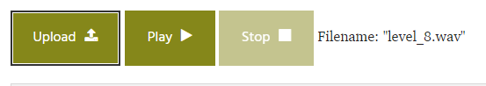

Figure 8.13

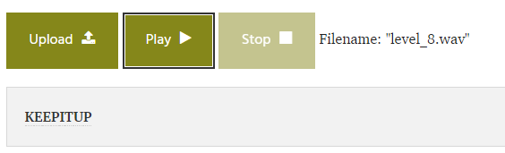

Figure 8.14

Once you get the flag submit it.

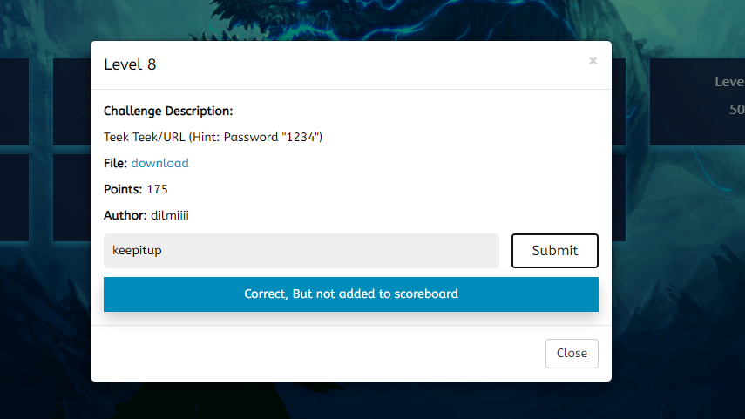

**LEVEL 9**

In this level the technology used is brute-force attack. You just have to guess the correct flag and submit the flag.

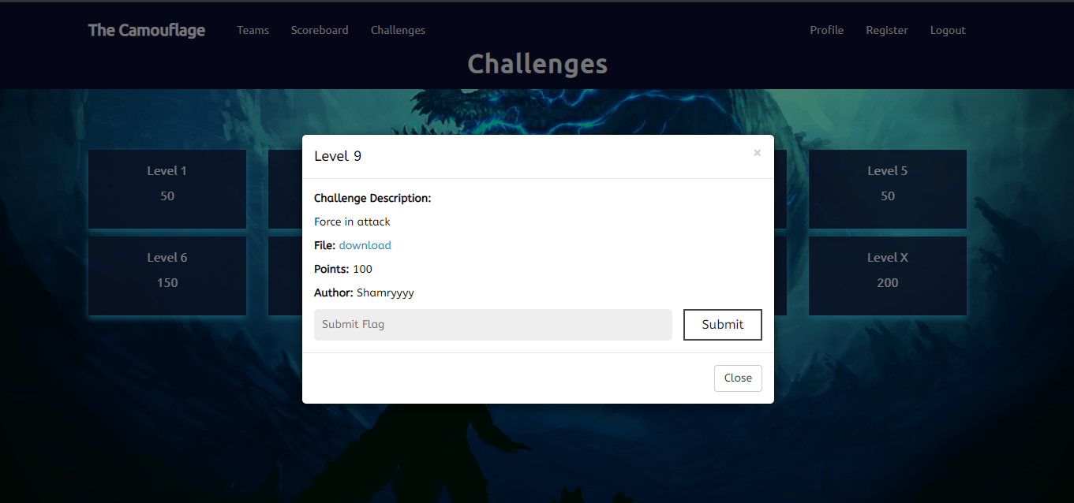

Figure 9.1

This is the downloaded image. Using this image you have to guess and type te correct password.

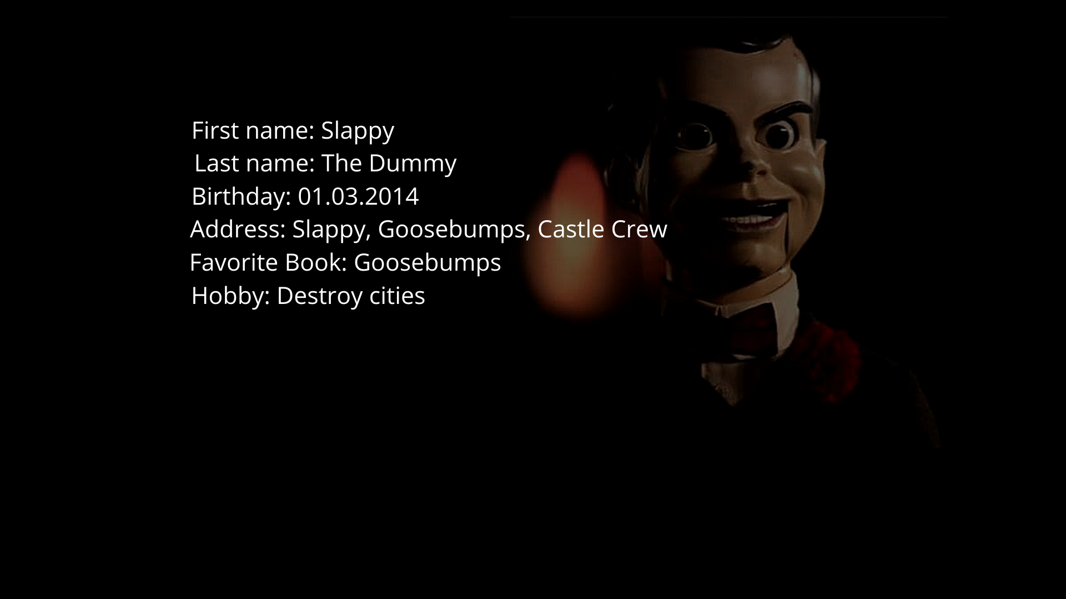

Figure 9.2

**LEVEL 10**

In this level you have to do is download the file and change two commands in the source code fie, and compile it, then you will get the flag.

Figure 10.1

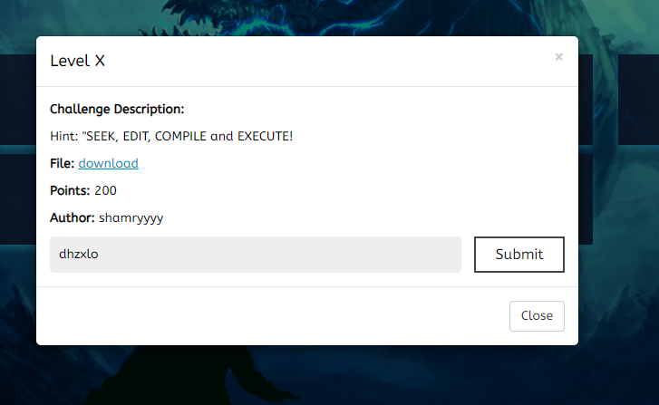

Download the file and extract it.



Figure 10.2



Figure 10.3

And there are two file which is a source code and an compile file.

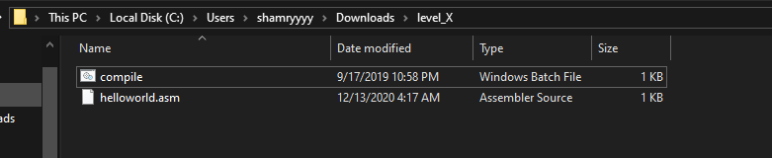

Figure 10.4

open the command prompt and compile the commands.

Figure 10.5

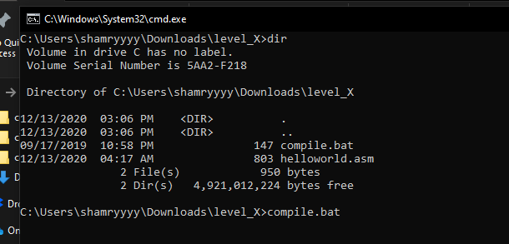

And you can see there are four file.

Figure 10.6

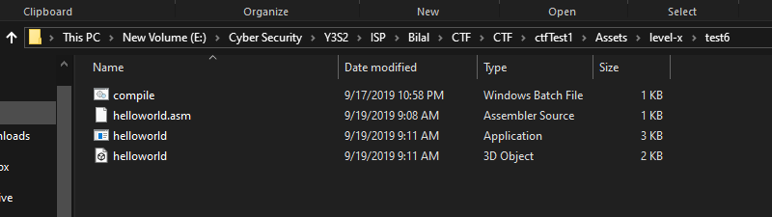

And run the executable file. (helloworld.exe)

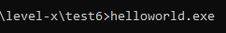

Figure 10.7

And then it will show you the flag.



Figure 10.8

Submit the flag in the level 10.

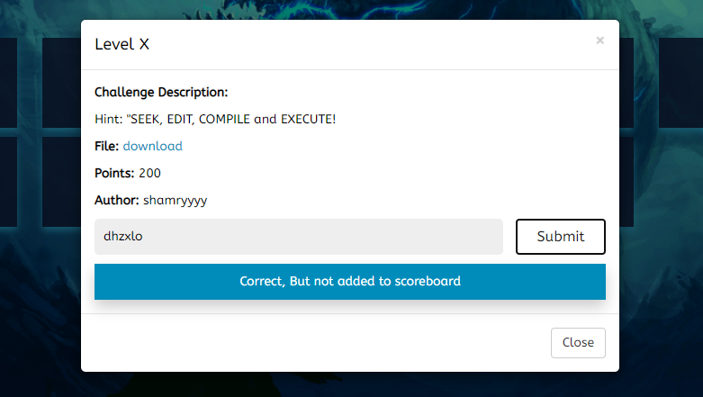

Figure 10.9

**Work Breakdown Table**

|  |  |  |  |  |
| --- | --- | --- | --- | --- |
| Task | Responsible person | Start date | End date | Duration |
| Information Gathering | Shamry & Dilmi | 03/08/20 | 08/08/20 | 5 days |
| Planning & Scheduling | Shamry & Dilmi | 09/08/20 | 11/08/20 | 5 days |
| Dashboard Implementation | Shamry & Dilmi | 15/03/20 | 25/03/20 | 10 days |
| Admin Panel Implementation | Shamry and Dilmi | 25/08/20 | 04/09/20 | 10 Days |
| Level(1,4,7,8,10) | Shamry | 06/09/20 | 13/09/20 | 7 Days |
| Level(2,3,5,6,9) | Dilmi | 07/09/20 | 15/09/20 | 8 Days |
| Testing | Shamry & Dilmi | 20/09/20 | 27/09/20 | 7 Days |
| Deploy online | Shamry & Dilmi | 01/09/20 | 23/10/20 | 23 Days |
| Documentation | Shamry & Dilmi | 25/10/20 | 30/10/20 | 5 Days |
| Video preparations | Shamry & Dilmi | 03/11/20 | 13/11/20 | 8 Days |

Github link

YouTube link: